**Assignment 25.4**

**Problem Statement:**

1. Write a hive query to find the top 20 destination people travel the most: Based on the given data.

2. Write a hive query to find the top 20 locations from where people travel the most.

**Input:**

You can download the dataset from the link below:

<https://drive.google.com/open?id=0ByJLBTmJojjzZEg2bXpYa0dyd1k>

**Output:**

Creating table travel_data in custom database and loading travel data into the table:

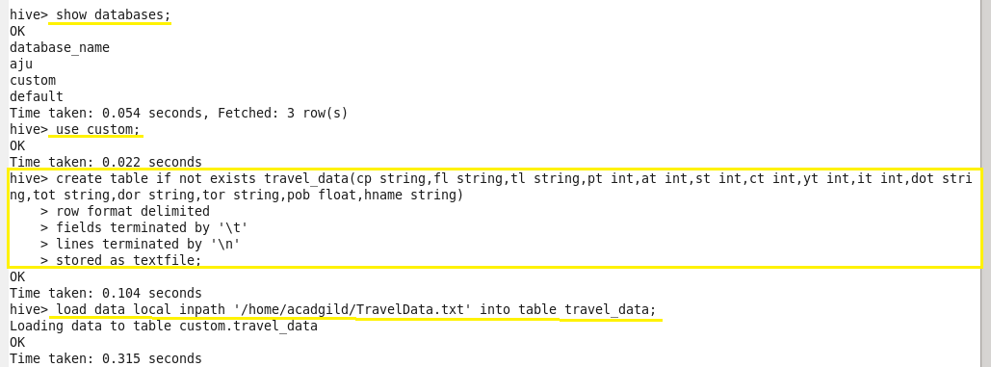

**Problem 1:**

Write a hive query to find the top 20 destination people travel the most: Based on the given data.

**Output 1:**

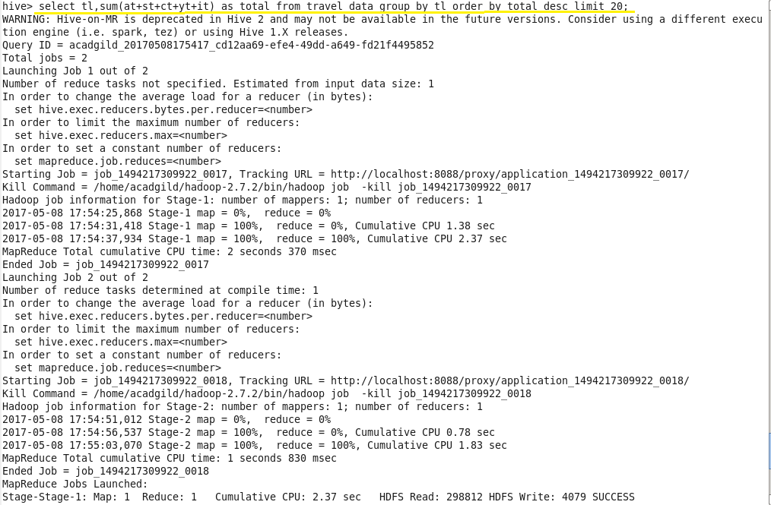

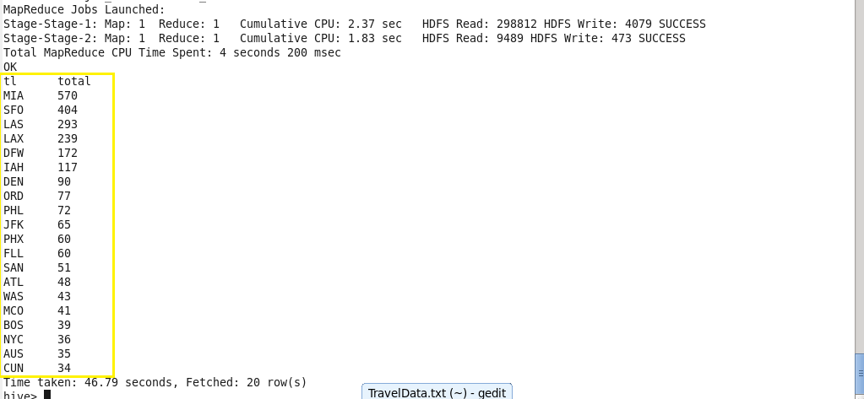

**Problem 2:**

Write a hive query to find the top 20 locations from where people travel the most.

**Output 2:**

